L

The Landing, Login, and Enrollment Pages Development Paper

Shanae Revell
The University of Arizona Global Campus
CST499: Capstone for Computer Software Technology
Charmelia Butler
February 16th 2026

The Landing, Login, and Enrollment Pages Development Paper
Web applications commonly rely on server-side technologies to manage user authentication, data storage, and dynamic content. In this project, I developed a basic user authentication system using PHP, MySQL, and XAMPP. The system includes a landing page, registration page, login page, and a protected dashboard that demonstrates session-based access control.
The goal of this project was to understand how PHP interacts with a MySQL database in a local development environment while following foundational software engineering practices. By implementing a custom database connection class and using prepared statements, this project applies secure and maintainable development techniques (Pressman & Maxim, 2020). XAMPP was used as the local development environment for this project. XAMPP includes Apache, MySQL, and PHP, which allows PHP files to be executed on a local machine. After installing XAMPP, the Apache and MySQL services were started through the XAMPP control panel. All project files were placed inside the htdocs directory so Apache could serve them. PHP files were run by navigating to http://localhost/CST499/filename.php in a web browser. This setup ensured that PHP scripts were processed by the server rather than displayed as plain text, confirming that the environment was correctly configured (Apache Friends, 2024).
The application consists of several core pages: a landing page (index.php), a registration page (register.php), a login page (login.php), and a dashboard page (dashboard.php). The landing page serves as the entry point and provides navigation to the login and registration pages. The registration page allows new users to create an account, while the login page authenticates existing users. After a successful login, users are redirected to the dashboard page, which is protected using PHP sessions. A logout page (logout.php) was also implemented to securely end the user session. All pages use a shared external stylesheet to maintain consistent layout, form styling, button design, and a subtle cream-colored background for a clean and modern user interface.
A MySQL database named CST499 was created using phpMyAdmin. Within this database, a users table was developed to store user account information. The table includes fields for a unique user ID, full name, email address, hashed password, and a timestamp indicating when the account was created. The email field was set as unique to prevent duplicate user accounts. Storing passwords in hashed form rather than plain text is a critical security practice in authentication systems (Pressman & Maxim, 2020). To improve organization and maintainability, a custom database connection class was created instead of embedding connection logic directly into each page. The Database class stores connection settings and provides a getConnection() method that returns a reusable MySQLi connection object.
This class-based approach reduces duplicated code and follows separation of concerns principles commonly used in software engineering (Sommerville, 2016). The MySQLi extension was used to establish the connection, and UTF-8 encoding was set to ensure proper character handling.
The registration page layout was designed using a simple form that collects a user’s full name, email address, and password. The layout was intentionally kept minimal to support usability and avoid unnecessary complexity.
The PHP logic behind the registration page handles form submission, input validation, password hashing, and database insertion. When the form is submitted, the application validates that all required fields are present. Passwords are hashed using PHP’s password_hash() function before being stored in the database. Prepared SQL statements are used to securely insert data and protect against SQL injection attacks (PHP Manual, 2024). After validation, user data is inserted into the users table using a prepared SQL INSERT statement. The database automatically assigns a unique ID and records the registration timestamp. Successful data transfer was verified by viewing the table contents in phpMyAdmin, confirming that PHP and MySQL were correctly integrated.
This project demonstrated the implementation of a basic authentication system using PHP and MySQL within a XAMPP environment. By developing structured pages, implementing a custom database connection class, and adhering to secure coding practices, the system demonstrates real-world web development fundamentals. Overall, this project strengthened my understanding of server-side development, database integration, and session management. The completed system provides a solid foundation that could be expanded with additional features such as course enrollment or role-based access control.

Screenshots

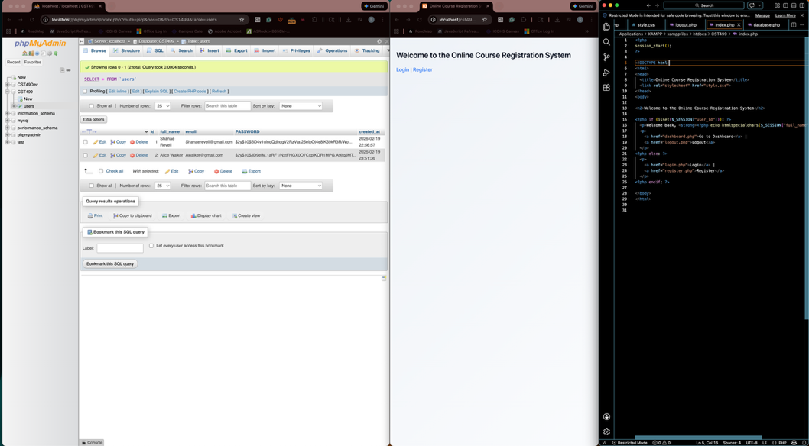
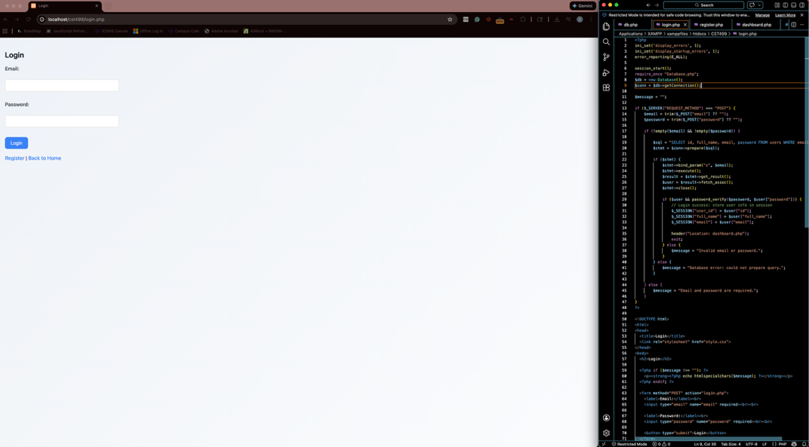
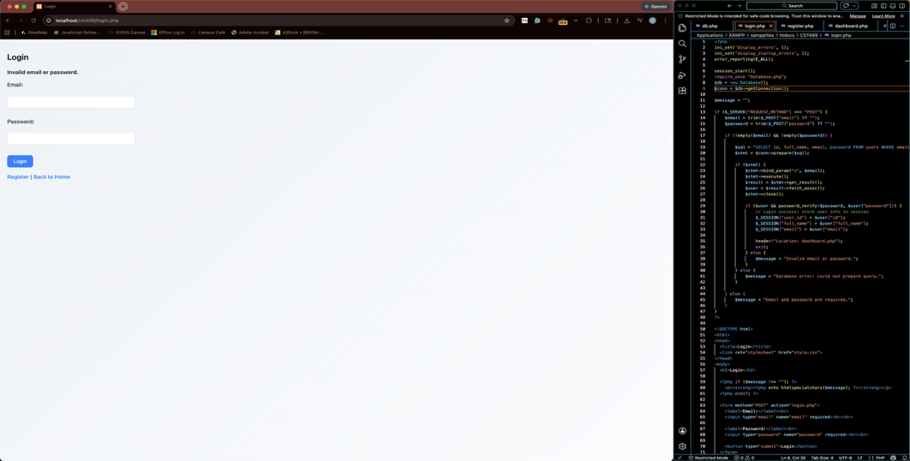
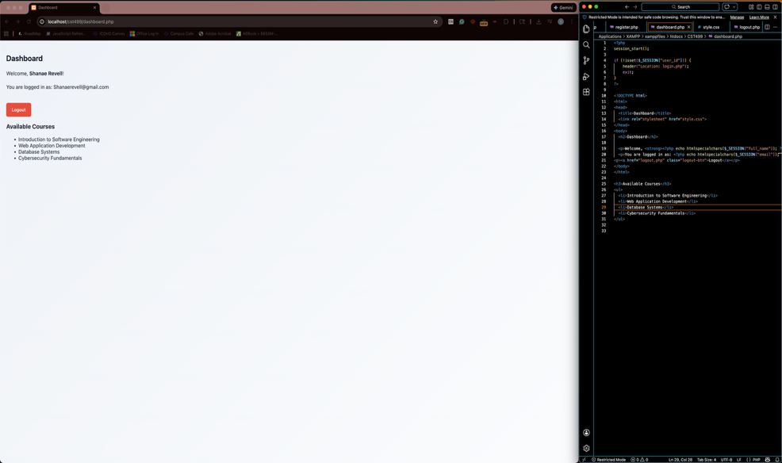
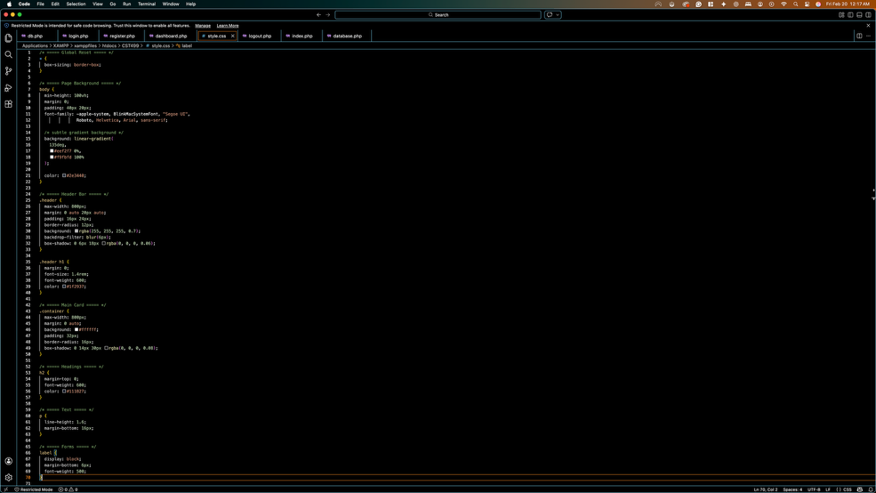
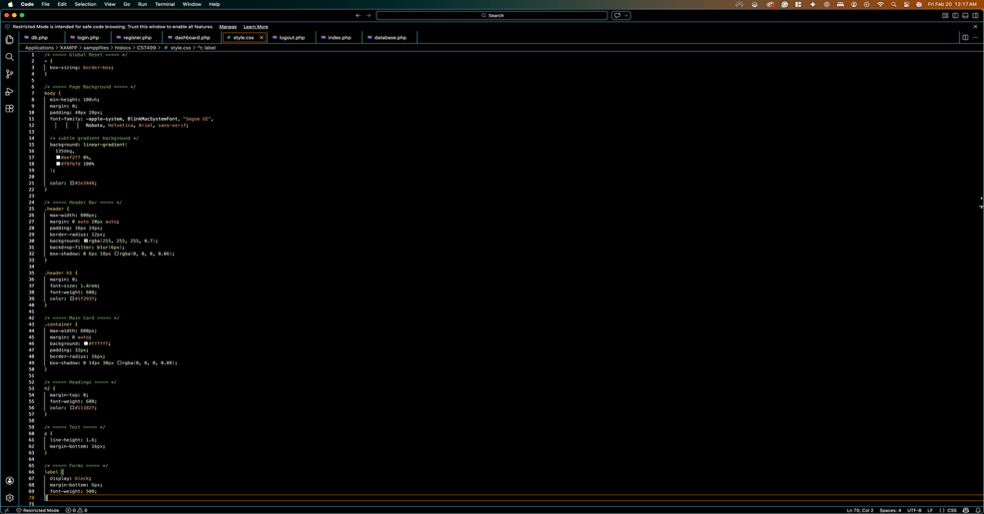

References
Apache Friends. (2024). XAMPP documentation. https://www.apachefriends.org

PHP Manual. (2024). MySQLi extension. https://www.php.net/manual/en/book.mysqli.php

Pressman, R. S., & Maxim, B. R. (2020). Software engineering: A practitioner’s approach (9th ed.). McGraw-Hill Education.

Sommerville, I. (2016). Software engineering (10th ed.). Pearson.

